Build an empathy map.

There are many tools a UX designer can use to empathize with users. Interviewing users is essential to understanding users’ perspectives and learning about their pain points, but that’s only the beginning of the UX research process. In this reading, you’ll learn about one of the many other tools designers can use to identify user needs: **empathy maps**.

As the previous video mentioned, you can create empathy maps for your projects. However, because empathy maps are one of many different tools designers use, they are optional for this part of the course. You are not required to submit any empathy maps for the upcoming CoffeeHouse or portfolio projects.

Remember, **empathy maps** are easily understood charts that explain what UX designers have learned about a particular type of user. Empathy maps can help break down each interview into digestible pieces of information.

**Empathy mapping in action**

Imagine your company is building a new app for scheduling dog walkers. The purpose of the app is to match qualified dog walkers with customers who need help caring for their dogs, similar to a ride-sharing or home-sharing app. You’re on the UX team, and your team is in the early stages of designing the app and understanding user pain points.

A colleague has already interviewed dog owners and professional dog walkers who are expected to use the app regularly. It’s now your responsibility to summarize each interview using empathy maps.

For this example, we’ll go through the steps to create an empathy map from an interview transcript. However, these same steps apply when creating an empathy map from an audio recording or interview notes. This is an example of an interview transcript with Makayla, a fourth-grade teacher with two dogs. You can read the entire transcript below, or you can reference the exemplar document below in a separate window to follow along as you complete the rest of the reading.

To view Makayla's interview transcript externally, you can find it below:

To access the transcript as a file, click the link below and select “Use Template.”

Link to exemplar: [Makayla interview transcript](https://docs.google.com/document/d/1ifW4B3Dd7wm-5L3it_L5-j5VXSq_E1RbysKr2sl--BI/template/preview).

**OR**

If you don’t have a Google account, you can download the exemplar directly from the attachment below.

**[Google UX Design Certificate - Makayla Interview transcript [Exemplar]](https://d3c33hcgiwev3.cloudfront.net/cS3ysnoGSHet8rJ6Bhh3wg_76a18fc229054de08d000a102a8dfaf1_Google-UX-Design-Certificate---Makayla-Interview-transcript-Exemplar-.docx?Expires=1682121600&Signature=b5QSQFVEcVr7jwBwiFM4VO87syHvg9w6RUdlg4bCWyg3BOxKsf3cMGbUBzi3QGBYjrQHB6FIVT~TkTtl6PGhErKEWZWe99McUJT9UYaD-L-YVBI9Ritz5k0I~Rc0eoiFWgvu-mdI-0Sxg0eu2ZVup4pql-dqE9fO-q~tl1mPGtM_&Key-Pair-Id=APKAJLTNE6QMUY6HBC5A" \t "_blank)**

[DOCX File](https://d3c33hcgiwev3.cloudfront.net/cS3ysnoGSHet8rJ6Bhh3wg_76a18fc229054de08d000a102a8dfaf1_Google-UX-Design-Certificate---Makayla-Interview-transcript-Exemplar-.docx?Expires=1682121600&Signature=b5QSQFVEcVr7jwBwiFM4VO87syHvg9w6RUdlg4bCWyg3BOxKsf3cMGbUBzi3QGBYjrQHB6FIVT~TkTtl6PGhErKEWZWe99McUJT9UYaD-L-YVBI9Ritz5k0I~Rc0eoiFWgvu-mdI-0Sxg0eu2ZVup4pql-dqE9fO-q~tl1mPGtM_&Key-Pair-Id=APKAJLTNE6QMUY6HBC5A" \t "_blank)



**Interview transcript**

Name: Makayla Scott

Situation: Makayla is a 45-year-old, female-identifying teacher who lives in Houston, Texas. She has two dogs. Makayla has a demanding job as a fourth grade teacher. She also volunteers as a volleyball coach after school. Makayla’s partner works full-time as a pediatric surgeon and regularly switches between working the night-shift and the day-shift at a local hospital.

***[UX Researcher]*** *Can you describe your current work situation and how you take care of your dogs?*

**[Makayla]** I work as a teacher, and I coach volleyball after school, so my puppers Reggie and Snowball are often left home alone for long periods of time. My partner works on-call in a hospital, which often means 12-hour day or night shifts. When our schedules overlap, we definitely need help walking Reggie and Snowball.

***[UXR]*** *What challenges do you face managing the care of your dogs? How does this make you feel?*

**[Makayla]** I *love* my dogs! They have so much energy. If it was up to them, they’d go on five walks a day! But, with our schedules, it’s hard to take them out as much as we’d like. I can manage taking them out first thing in the morning and again in the evening. Sometimes, I pay my next door neighbor’s 17-year-old son to walk them. But, the real issue comes from our travel schedule. My partner and I like to take a lot of trips, and we can’t always take our pets with us. Planning our trips would be much easier if we could book a dog walker.

Our neighbor’s son is graduating this year, and his schedule is becoming inconsistent. I can’t rely on him at the last minute, and I worry that he doesn’t really have the right experience for when I’m on longer trips. I mean, sure, a 17-year-old kid is fine for daily walks. But what if he takes the dogs for a weekend and Snowball gets sick? How will he know what to do, or if he should call me? It definitely makes me worry, but I can’t spend the money on a doggy daycare.

There are also a lot of places I can’t bring Reggie, who is a much bigger dog than Snowball. He’s not hypoallergenic like Snowball is. And, because he’s so big, even bringing him on road trips can be a struggle. We just moved to Houston last year, and there aren’t many people we can ask for help. I’ve considered putting up an ad online, but I’m not sure how I would know who’s safe to allow in my home or who’s good with dogs.

***[UXR]*** *Is there any way in which you feel these challenges could be resolved?*

**[Makayla]** I’d love to find a dog walker that I could prescreen and learn more about. And I’d love a way to book someone consistently. Maybe someone who can do weekends regularly and can commit to specific times while I’m working. Ideally, I could schedule dog sitting days in advance. I just need a consistent dog walker that I can screen to make sure they’re safe and good with animals! I’m willing to pay a little more to get something like this instead of constantly requesting help from my neighbor.

**Creating an empathy map**

Now that you’ve had a chance to review Makayla’s interview transcript, let’s break down the steps for creating an empathy map. As a reminder, here’s what an empathy map includes:

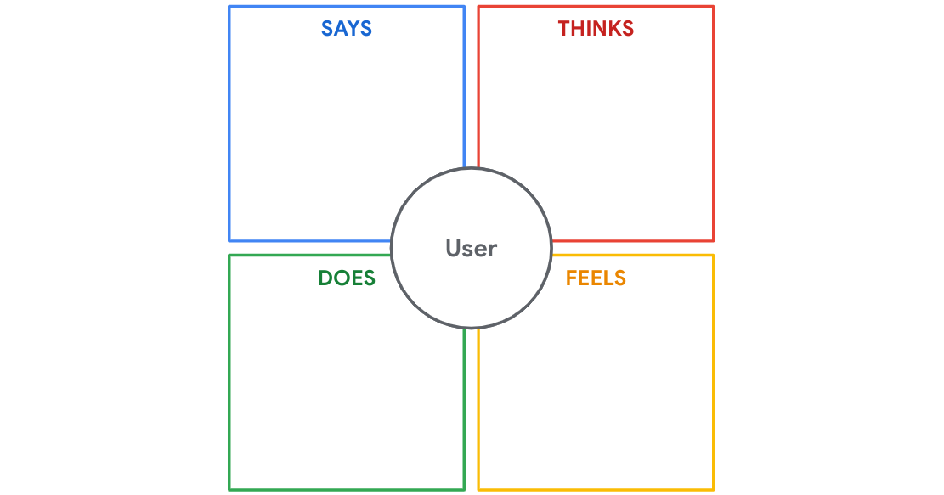

You can fill out this empathy map with a handful of steps.

**Step 1: Add the user’s name.** Include the name of the person interviewed in your empathy map. Having a name attached to it will help if you ever need to look back at the original transcript or research, and it’ll distinguish this map from other maps you create.

**Step 2: The “SAYS” square.** Use verbatim quotes from the interview. In other words, write down exactly what the person said; don’t summarize it in your own words. If you summarize a quote, you might accidentally interpret the user’s meaning incorrectly. It’s also helpful to try to capture themes in the interview that relate to the product you’re researching. For example, if the user restates the same problem several times during the interview, then it’s probably a major pain point. Pay special attention to challenges your user states, and record any desired benefits or expectations they mention.

**Step 3: The “THINKS” square.** Here, you can summarize the thoughts expressed by the user. Add feelings the user conveyed through body language, tone, or other noticeable indicators, even if they didn’t verbally express them to you. You can make inferences for some of these feelings, but you have to be careful not to make assumptions about the user. For example, Makayla expressed concern about her neighbor’s teenage son and mentioned his age and qualifications. An assumption is that Makayla wants an adult dog walker. An inference is that she wants a dog walker with a car and a driver's license who can take the dog to the emergency vet. You can always ask your user for clarification on their body language if you find any contradictions.

**Step 4: The “DOES” square.** Makayla gave us quite a bit of detail on steps and actions she takes to overcome the dog-walking challenges she faces. All those actions can go in the “DOES” square.

**Step 5: The “FEELS” square.** List the feelings the user expresses. The notes you include may overlap with some of what you listed in the “THINKS” square. That’s okay! This process is meant to be a thorough documentation of your observations. If you’re the person performing the interview, you might notice signs of feelings like anger, frustration, excitement, and others. If the user doesn’t explicitly mention any feelings during the interview, you can probe for feelings with the question: “How does this make you feel?”

**Empathy map example for Makayla**

Now that you’ve reviewed the interview transcript and the steps for creating an empathy map, let’s use our template to take action! Here’s an empathy map for Makayla:

**SAYS**

* “I’m not sure how I would know who’s safe to allow in my home or who’s good with dogs.”
* “I’d love to find a dog walker that I could prescreen.”
* “I’d love a way to book someone consistently.”
* “Ideally, I could schedule dog-sitting days in advance.”
* “...there aren’t many people we can ask for help”
* “I’m willing to pay a little more to get...this”

**THINKS**

* Wants to book recurring dog walkers
* Would like to prescreen dog walkers
* Would like to find dog walkers in advance
* Dog walking is expensive
* Would like a dog walker who has experience with animals
* Doesn’t know enough people to ask them to walk her dogs
* Wants a more consistent dog walker

**DOES**

* Works a full-time job as a teacher
* Walks her dogs first thing in the morning and evening
* Pays her neighbor, a 17-year-old high school student, to walk the dogs

**FEELS**

* Guilty when she can’t take her dogs for walks
* Sad she can’t spend more time with her dogs
* Sad she can’t take her dogs on vacation
* Worried about finding a consistent, dedicated dog walker that can commit to her schedule
* Worried about her larger dog’s needs
* Worried about her current dog walker’s ability to manage a potential sudden illness in her dog

This empathy map breaks down all the points that your team will need to determine how your app can meet Makayla’s needs. The real challenge starts when you lay out the empathy maps from all of your user interviews and figure out how each of your potential users’ needs overlap.

**Types of empathy maps**

It's important to understand that there are two types of empathy maps: **one-user empathy maps** and **aggregated empathy maps** (also known as"multiple-user empathy maps"). One-user empathy maps are created by taking the data from one user's interview and turning it into an empathy map, like the example earlier in this reading. This approach helps designers distill a single user's thoughts, feelings, and traits into a format that's easier to gather data from.

The other kind of empathy map, an aggregated empathy map, represents a group of users who share similar thoughts, opinions, or qualities. Aggregated empathy maps are created by creating multiple one-user empathy maps, then combining the maps where users expressed similar things into a new empathy map. This helps designers identify segments, or groups of people with similar tendencies, who will use the product. The insights in aggregated empathy maps allow designers to identify themes, which helps them better empathize with the groups they are designing for. To learn more about the different kinds of empathy maps, check out this article on [empathy mapping](https://www.nngroup.com/articles/empathy-mapping/) from the Nielsen Norman Group.

You’re beginning to understand what it means to empathize with your users. Each time you interact with a potential user, you get a little closer to understanding their perspectives and pain points. Good luck!

# Case studies: Products that address pain points

To learn more about user pain points, check out these real-world case studies from Google and Airbnb. Try to identify the unique pain points that led to major design changes!

* Read about the methodology behind the 2016 [Google Font redesign](https://design.google/library/reimagining-google-fonts/).
* Learn about how a new color system helped [simplify Google Maps](https://design.google/library/exploring-color-google-maps/) and make it more accessible.
* Examine how [Airbnb revamped their product design](https://airbnb.design/designing-for-a-changing-world/) in response to the ways in which the world changed during the COVID-19 pandemic.